**Introduction**

This file contains the screenshots for all the steps done during implementing project Deploy Static Webite on AWS

**Amazon S3-bucket**

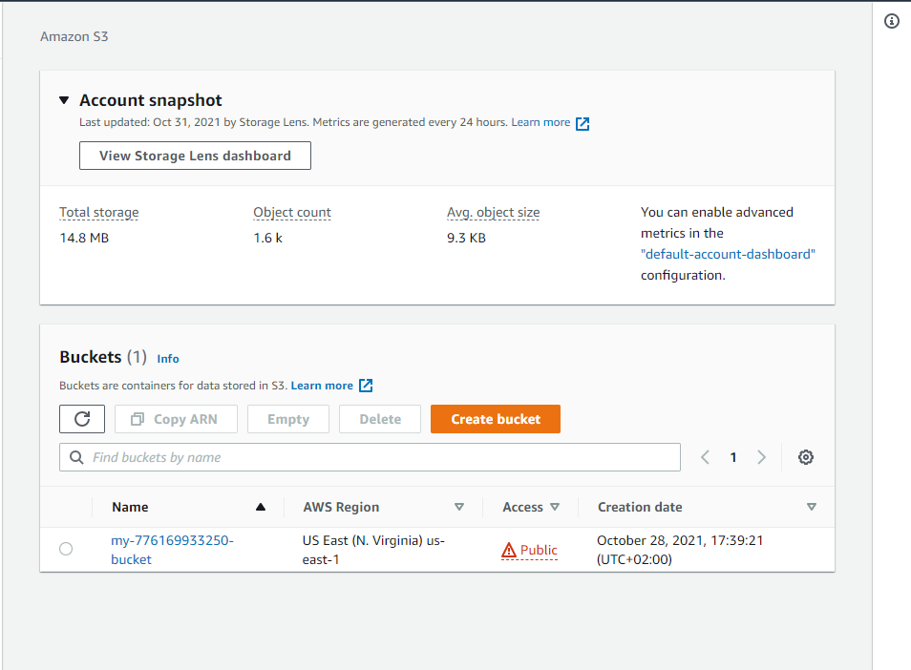

**Bucket files**

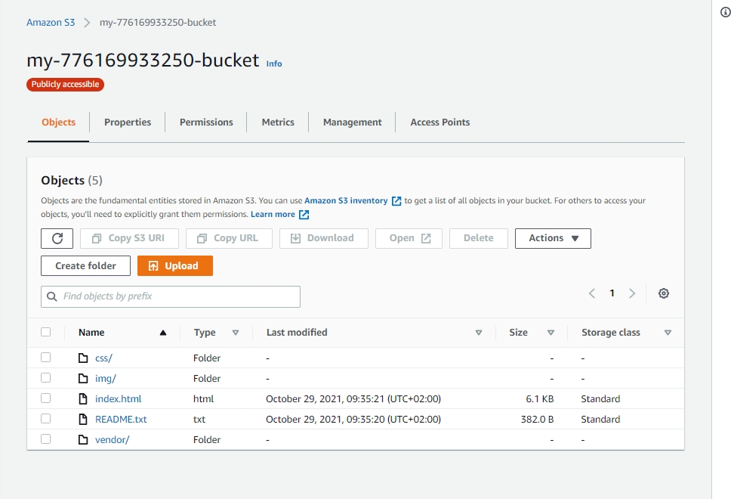

**Bucket permissions**

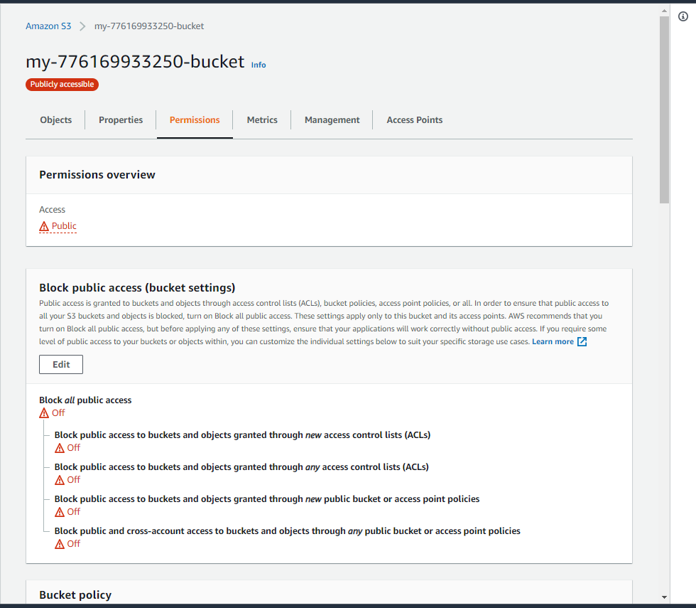

**Bucket policy**

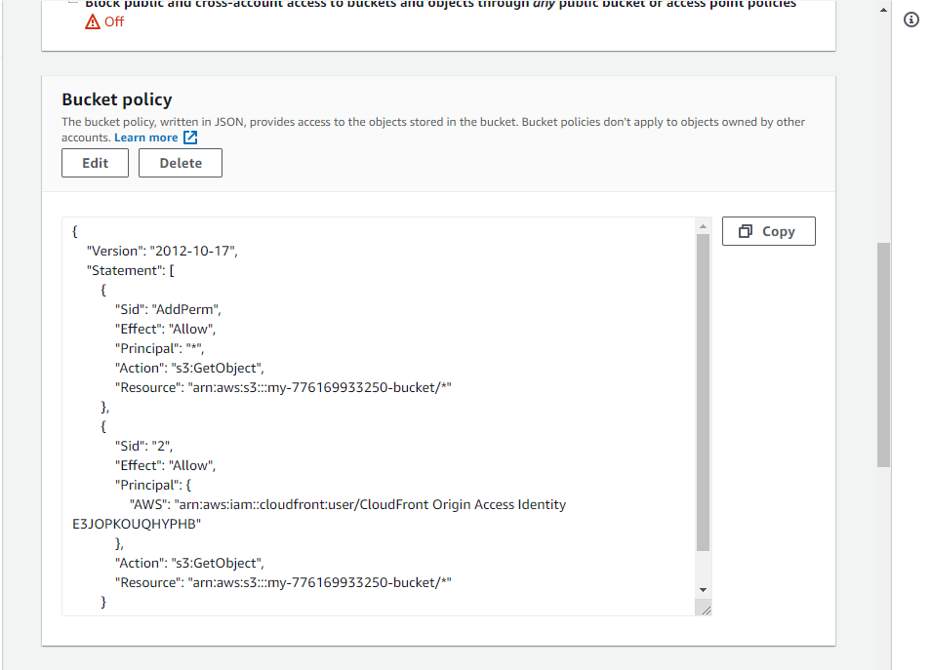

**CloudFront distribution**

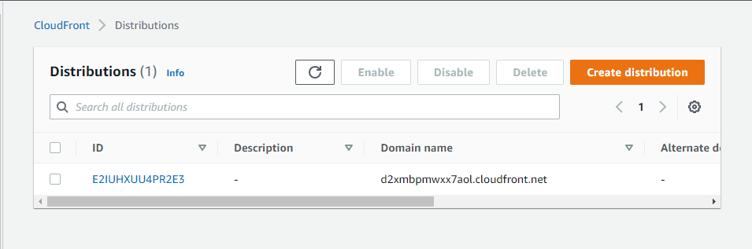

**CloudFront distribution Status**

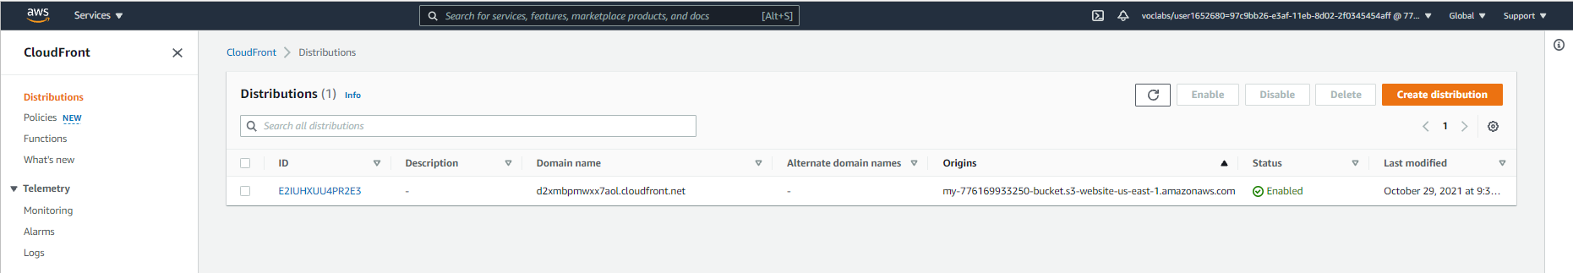

**CloudFront distribution details**

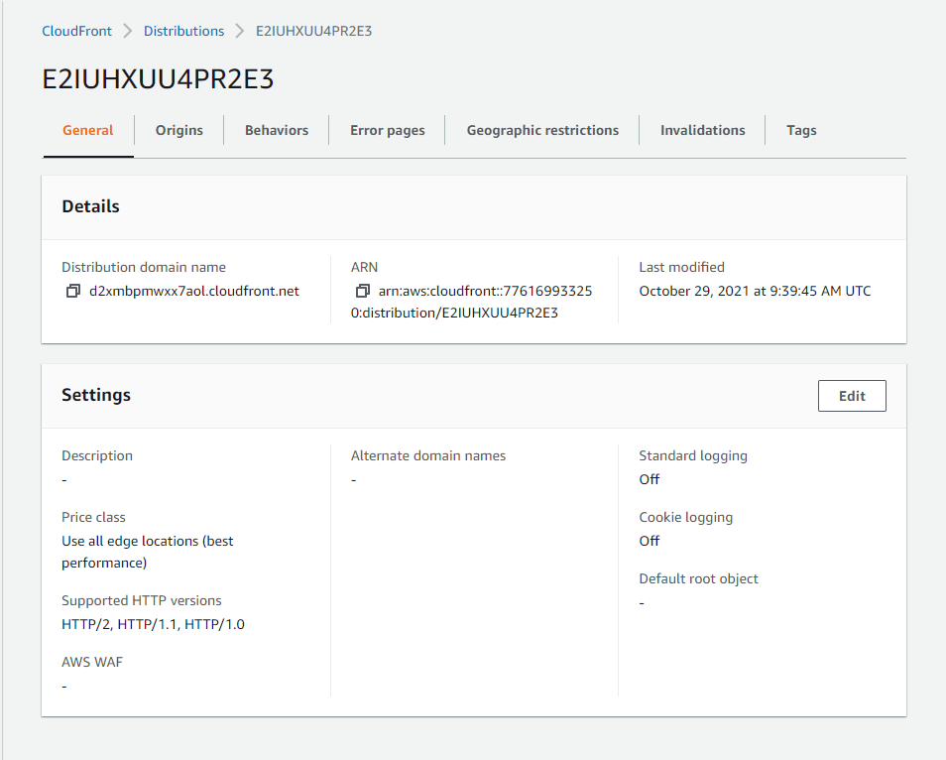

**Bucket Static web page**



**CloudFront CDN URL**

**S3-index.html URL**

